**Idea/Approach Details**

**Department Category:** Education Department

**Problem Statement:** GPS based Vehicle Tracking System for school children

**Team ID:**

**Team Leader Name:** Paresh Vinubhai Vala

**College Name:** Birla Vishvakarma Mahavidyalaya (V.V.Nagar)

**College Code:** C347

1. **How will you solve the problem (Methodology)**

* We will design an admin web app where he will design the route for the bus driver.
* Admin will also register all the students in the database along with parents contact number, route and pickup point, address and the name of driver and bus number.
* The admin will register the driver as well with his contact details. Admin will set a specific route and assign a bus and driver to it.
* The bus will have a mobile phone connected to it and driver will login and share the location. The parents can track the bus with their android app.
* Parents will also get all the important announcement that will be shared by the admin.

1. **Flow Diagram of Solution (you can add supportive diagram to justify your solution if prepared)**

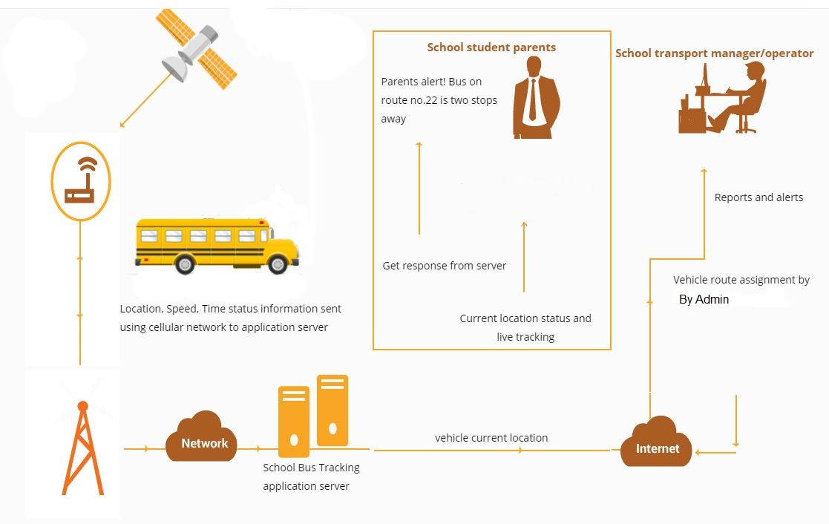

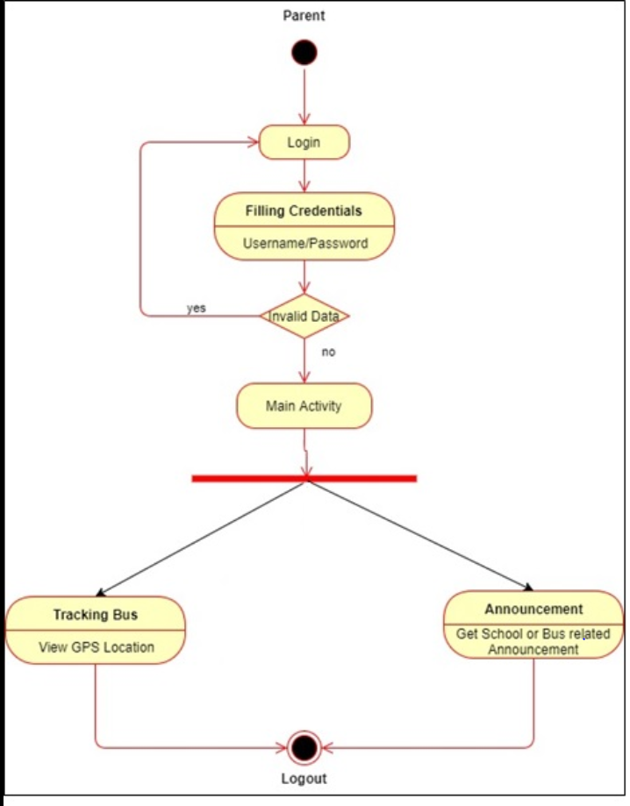

1. **Tools and Technologies to be used (Mention if any special software/Hardware you are going to use)**

* Tools : Android Studio , Android Mobile (GPS), Wamp Server , Dream Viewer
* Technologies : Android , Java , PHP , JS , HTML5 , CSS3 .

1. **Possible outcome of your work.**

* We will have 1 web app for Admin who will manage students , bus , driver , announcement and route management.
* We will have an android app for parents which will track the bus and display important announcement.
* There will be an android app for driver who will share his location and get announcement done by the admin.

1. **Challenges/Risk in implementing your Final prototype.**

* The only requirement and need for our project to run is to get internet connectivity.

1. **Work done till date.**

**We designed the prototype of admin panel. We have built database and done login from the parents app.**

1. **Image/Screenshot/Video link of your solution (If any)**

